Raster Image

📘 Definition
# Source: AI Source: Provided by: [Data Path: Persons Table -> ID Column: 1, Name_En Column: Motasem Essam] -> From: [ChatGPT] on [5/2/2026]
A Digital (Raster) Image is an image made up of a grid of tiny squares called pixels. Each pixel has its own color, and together they form a complete picture.

🔍 How raster images work
# Source: AI Source: Provided by: [Data Path: Persons Table -> ID Column: 1, Name_En Column: Motasem Essam] -> From: [ChatGPT] on [5/2/2026]
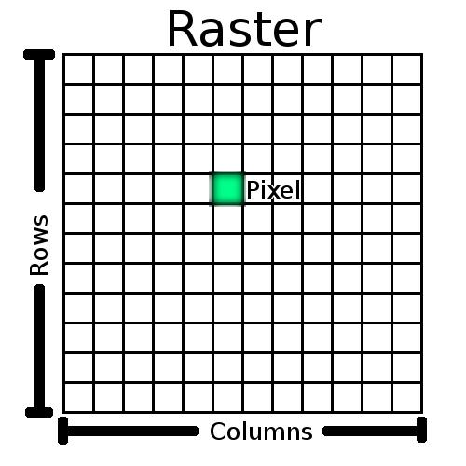
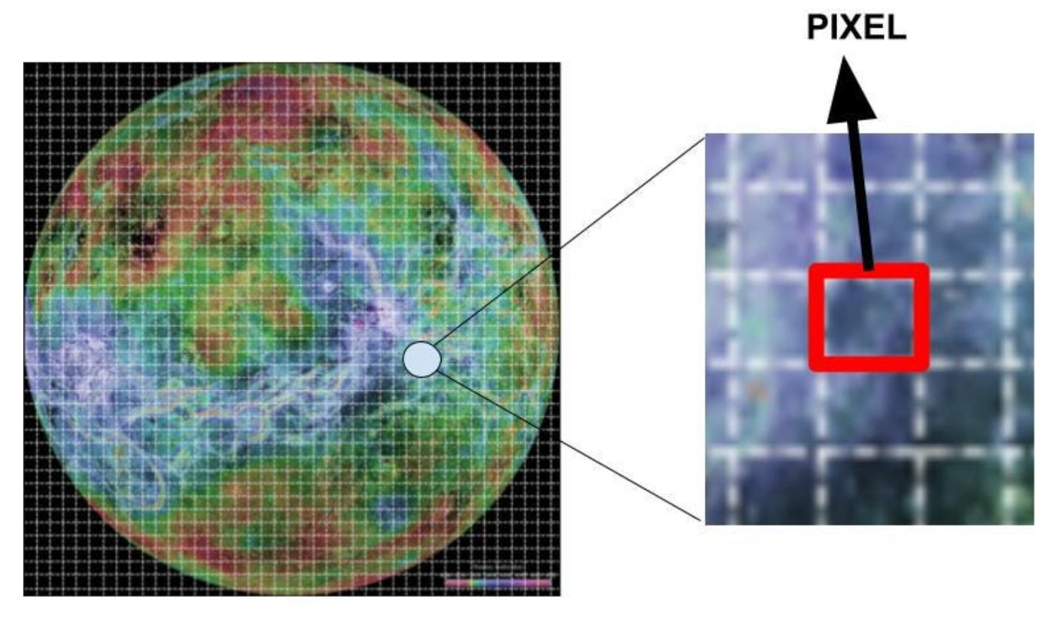
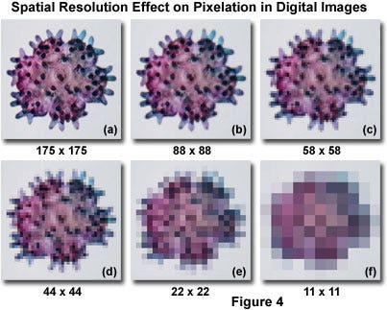
- The image is divided into small pixels
- Each pixel stores a color value
- When combined, they form a full picture
- More pixels = higher quality image

🧠 Simple example
# Source: AI Source: Provided by: [Data Path: Persons Table -> ID Column: 1, Name_En Column: Motasem Essam] -> From: [ChatGPT] on [5/2/2026]
Think of:
- 📸 A digital photo on your phone
- 🖥️ A computer screenshot
- 🎮 Game textures (like grass, walls, sky)
If you zoom in very close, you see tiny colored squares (pixels).

🎮 Where raster images are used
# Source: AI Source: Provided by: [Data Path: Persons Table -> ID Column: 1, Name_En Column: Motasem Essam] -> From: [ChatGPT] on [5/2/2026]
- 📱 Photos and camera images
- 🖥️ ScreenShot and wallpapers
- 🎮 Game textures and graphics
- 🎬 Movies and digital art

⚙️ Key features
# Source: AI Source: Provided by: [Data Path: Persons Table -> ID Column: 1, Name_En Column: Motasem Essam] -> From: [ChatGPT] on [5/2/2026]
- 🟦 Made of pixels (tiny dots)
- 🎨 Each pixel has a color
- 🔍 Quality depends on resolution
- ⚠️ Can become blurry when enlarged too much

🚀 In short:
# Source: AI Source: Provided by: [Data Path: Persons Table -> ID Column: 1, Name_En Column: Motasem Essam] -> From: [ChatGPT] on [5/2/2026]
Digital (Raster) Image = an image made of many tiny colored pixels arranged in a grid to form a picture.

